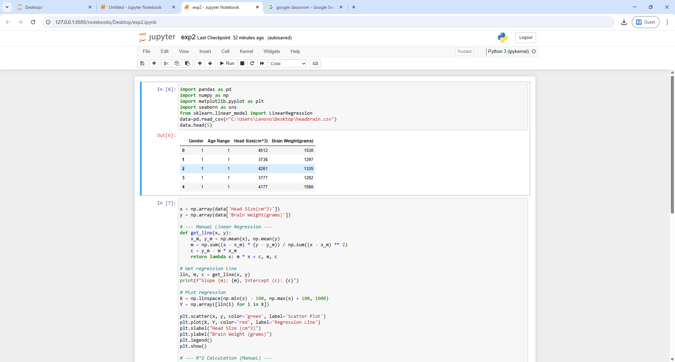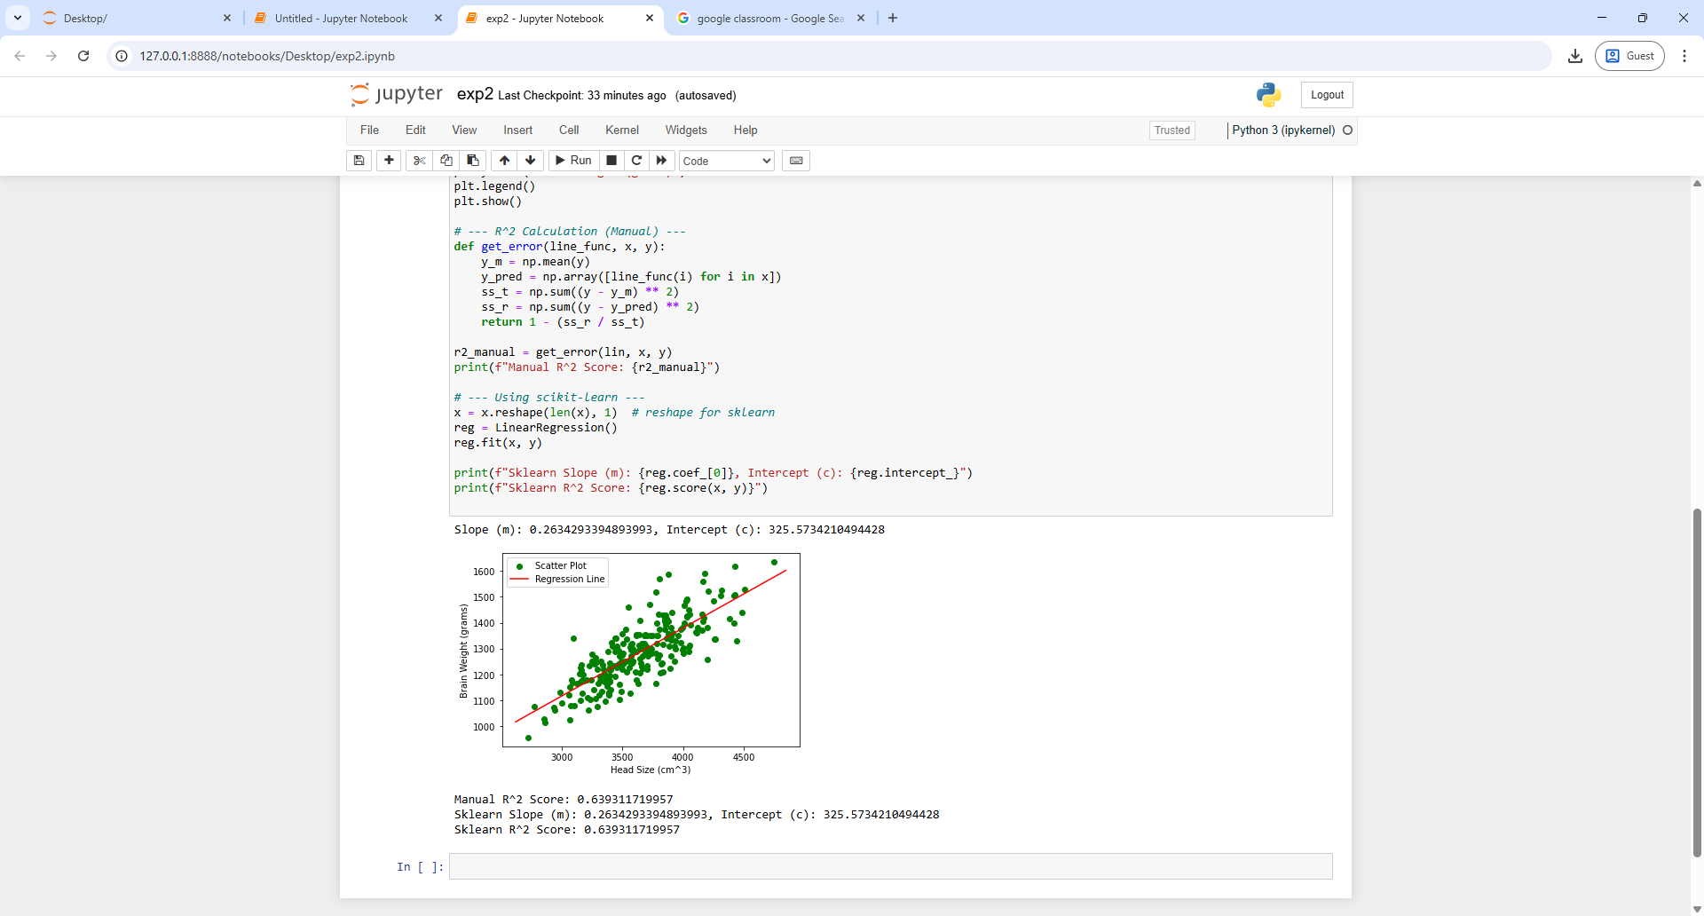

EXPERIMENT 2

A PYTHON PROGRAM TO IMPLEMENT SIMPLE LINEAR REGRESSION USING LEAST SQUARE METHOD